Semester One – Week 5:
The concept of the Golden Thread in your study

These notes guide you to:
• Explain the Golden Thread as a coherence and alignment principle in research writing.
• Identify where the Golden Thread commonly breaks (misaligned language, design, and questions).
• Apply a practical checklist to test alignment between title, problem, questions, objectives, methods, analysis, and conclusions.
• Use strategies to maintain and repair coherence while a study evolves over time.

Core idea:
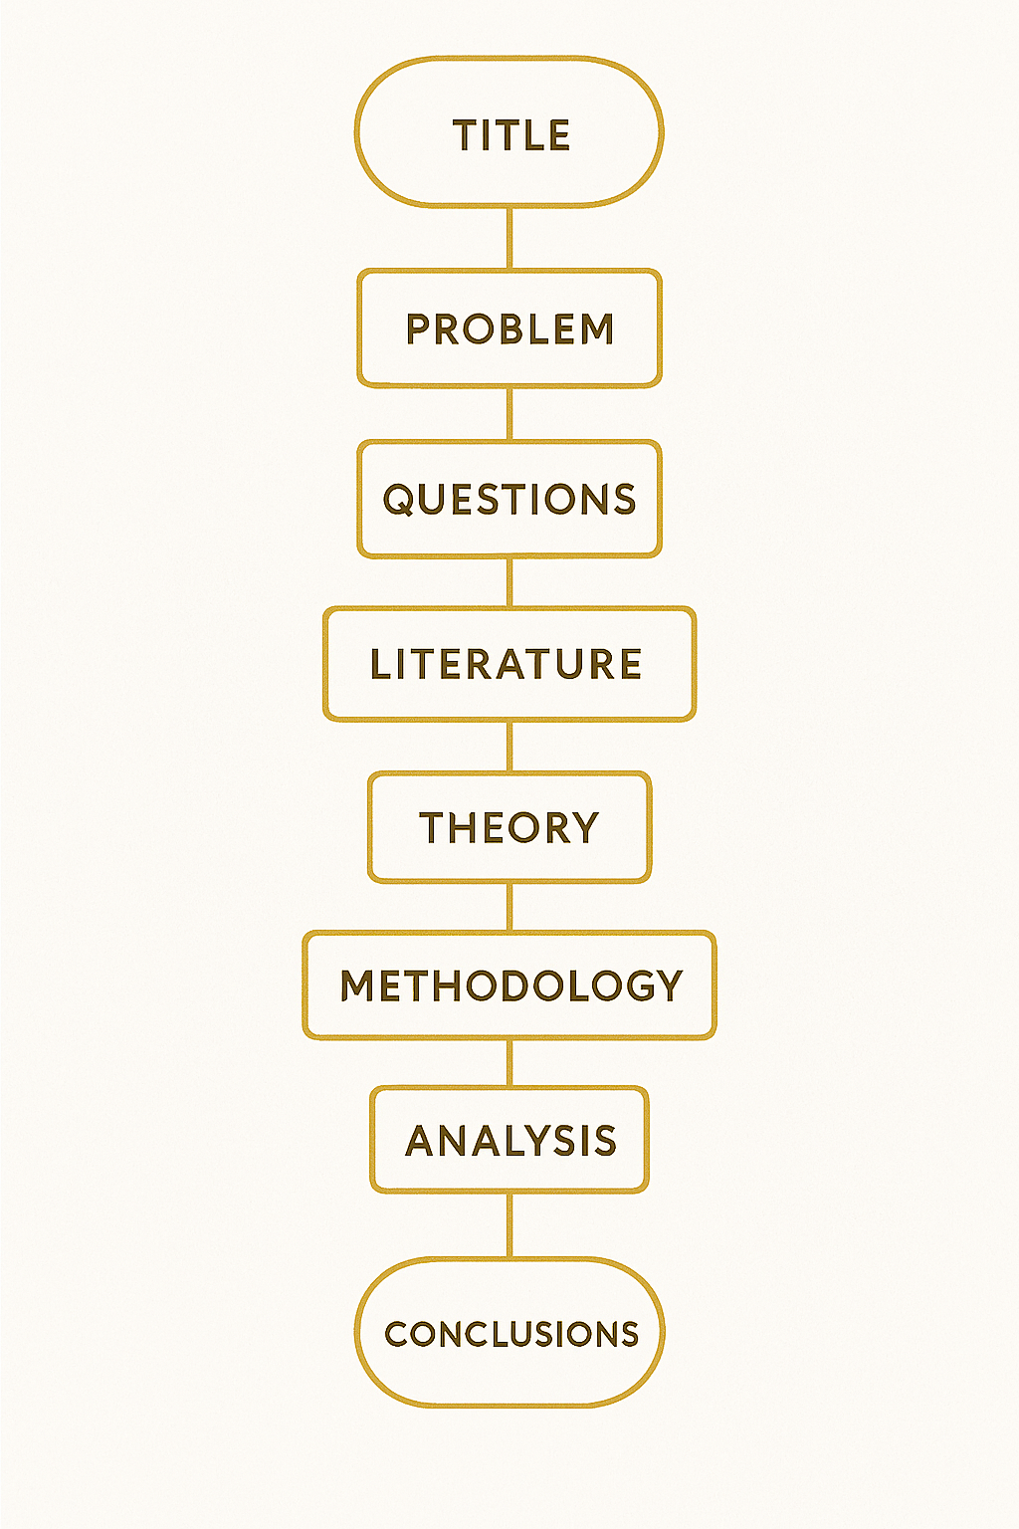
The Golden Thread is the line of logical coherence that connects every part of a research project, from the title and problem, through questions, objectives, literature, theory, methodology, analysis, and conclusions. (Francke, 2024; Clarence, 2015; Spooner & Barnard, 2024)

A. Why is the Golden Thread important in research?
- It prevents the study from becoming a collection of disconnected parts.
- It helps the reader see clearly what question you asked, why it matters, and how you answered it.
- It supports validity and reliability by ensuring that each step is logically justified and linked to the overall aim. (Francke, 2024)

B. The essence of the Golden Thread
Think of the Golden Thread as a guiding line running through your entire project:
- Research title (the central focus in a few words)
- Research problem (the issue or gap that makes the study necessary)
- Research questions (what you need to answer to address the problem)
- Objectives (what you will do to answer the questions)
- Literature and theory (the concepts and scholarly conversation that frame your argument)
- Methodology (how you will produce evidence that answers the questions)
- Data analysis and findings (how evidence is interpreted in relation to the questions)
- Conclusions and implications (how the study resolves the problem and explains significance)
This is the central argument that pulls through the whole study, creating coherence across chapters. (Clarence, 2015)

C. Importance of consistency across the research components
- Title to problem
• The problem statement must directly relate to the topic signalled by the title. (Francke, 2024)
- Problem to questions
• Research questions are derived from the problem and specify what must be investigated. (Francke, 2024)
- Questions to objectives
• Objectives translate questions into achievable steps. If an objective is not linked to a question, it will not be investigated. (Francke, 2024)
- Literature and theory to questions
• Literature and theory should be selected because they help answer the research question and justify the study. (Clarence, 2015)

D. Alignment in methodology
- Data collection choices must be driven by the research questions and objectives, not by convenience or habit. (Francke, 2024)
- Analysis techniques must be appropriate for the type of data and must directly answer the research questions. (Francke, 2024)
- A Golden Thread breaks when the research design does not match the promised approach, for example, exploratory qualitative framing paired with hypotheses and variables, or explanatory quantitative designs paired with open-ended why and how questions. (Spooner & Barnard, 2024)

E. Drawing conclusions that tie back
• Conclusions must answer the research questions and meet the objectives.
• Implications must follow logically from the findings, not from personal preference.
• Readers should not finish your work asking: “So what? Why did I read this?” The Golden Thread is the answer to that question. (Clarence, 2015)

F. Transparency and clarity
• Your reader should be able to trace how each part of the study leads to the next with no gaps or contradictions. (Francke, 2024)
• Write as scientific communication: communicate the research contribution itself, not the full intellectual history of every false start. (Spooner & Barnard, 2024)
• Use practical reminders to stay on track, for example keeping the main research question visible while writing so you do not drift into interesting but irrelevant detail. (Clarence, 2015)

G. Analogy: a lawyer in court
The Golden Thread is like a well-constructed legal argument:
• Clear evidence supports claims (data support research questions).
• Logical reasoning connects evidence to claims (analysis links data to questions).
• A verdict follows logically from evidence and reasoning (conclusions follow from findings). (Francke, 2024)

H. Practical Golden Thread checklist
- Does the title match the problem statement in focus and scope?
- Does the problem clearly state the gap, broken practice, or missing knowledge?
- Do research questions flow from the problem and stay within the same approach (qualitative or quantitative)?
- Does each objective map to a research question (one-to-one where possible)?
- Is the literature review organised around concepts that help answer the question?
- Does the methodology produce evidence that can answer each question?
- Does the analysis explicitly return to the research questions and objectives?
- Do conclusions and recommendations follow from findings and address the original problem?

I. Where the Golden Thread commonly breaks, and how to repair it
1. Break: Design language mismatch
• Example: exploratory qualitative study framed with hypotheses and variables, or quantitative explanatory study framed with open-ended why and how questions. (Spooner & Barnard, 2024)
• Repair: rewrite questions and objectives so the language matches the design, then adjust methodology and analysis to fit.
2. Break: Findings introduce a new central theme that the literature review did not prepare for
• Repair: update the literature review to prepare the reader, and revise the research question if needed, while keeping logical integrity. (Spooner & Barnard, 2024)
3. Break: Unexpected or non-significant results feel like failure
• Repair: keep the evidence unchanged, explain what the results mean in relation to prior literature, and refine the argument rather than forcing a preferred story. (Spooner & Barnard, 2024)
4. Break: Writing drift
• Repair: keep the main research question visible while drafting, and check each paragraph for relevance to the question. (Clarence, 2015)

J. Examples of a Good Golden Thread and a Bad Golden Thread
Example 1: Good Golden Thread (Aligned)
I. Title → Problem (Aligned)
Title: Cybersecurity Awareness Training and Phishing Risk Among University Students
Problem: Universities experience phishing incidents affecting student accounts. Although training is provided, it is unclear whether current awareness training reduces students' susceptibility to phishing.

II. Problem → Questions (Aligned)
Main Research Question: How does cybersecurity awareness training influence phishing susceptibility among university students?
Sub-questions:
- What training components are most associated with improved phishing recognition?
- What outcomes are used to measure susceptibility?

III. Questions → Objectives (Aligned)
Main Aim: To explore how cybersecurity awareness training influences phishing susceptibility among university students.
Objectives:
- To identify what training components are most associated with improved phishing recognition.
- To synthesise evidence on outcomes used to measure phishing susceptibility.

IV. Literature/Theory → Questions (Aligned)
The literature focuses on phishing behaviour, the design of awareness training, user security behaviour, and evaluation measures, as these directly help answer the questions.
Why this is good: Every element uses the same focus, population, and outcome, and each part clearly supports the next.

Example 1: Bad Golden Thread (Misaligned)
I. Title → Problem (Broken)
Title: Cybersecurity Awareness Training and Phishing Risk Among University Students
Problem: The organisation lacks a firewall and needs intrusion detection to prevent malware infections.
Why it is bad: The title is about training and student phishing, but the problem is about technical infrastructure. The study starts in one direction and then immediately shifts.

II. Problem → Questions (Broken)
Research Question: What firewall solution is most secure for a university network?
Why it is bad: The question has shifted entirely to network engineering and product selection, which the title did not promise.

III. Questions → Objectives (Broken)
Objective: To test three firewall brands and select the best one.
Why it is bad: The objective is now a procurement decision rather than a research investigation aligned with the original topic.

IV. Literature/Theory → Questions (Broken)
The literature mostly focuses on firewall architecture, IDS/IPS tools, and network segmentation, rather than awareness training or phishing susceptibility.
Why it is bad: The thread is broken at every step because the topic keeps changing.

Example 2: Good Golden Thread (Aligned)
I. Title → Problem (Aligned)
Title: AI Coding Assistants and Code Reliability in Software Teams
Problem: Many software teams adopt AI coding assistants to increase speed, but developers raise concerns about reliability and increased verification workload. Evidence is fragmented and inconsistent.

II. Problem → Questions (Aligned)
Main Research Question: What is the impact of AI coding assistants on code reliability in software teams?
Sub-questions:
- What reliability risks are reported in software teams?
- What safeguards or governance practices are recommended in software teams?

III. Questions → Objectives (Aligned)
Main Aim: To explore the impact of AI coding assistants on code reliability in software teams.
Objectives:
- To identify reliability risks reported in software teams.
- To identify safeguards or governance practices recommended in software teams.

IV. Literature/Theory → Questions (Aligned)
The literature focuses on human-AI collaboration in coding, code quality metrics, software assurance, and governance because these directly address the question.

Example 2: Bad Golden Thread (Misaligned)
I. Title → Problem (Broken)
Title: AI Coding Assistants and Code Reliability in Software Teams
Problem: Many students struggle with mathematics in high school.

Why it is bad: The problem statement is from a different domain. There is no logical connection to the title.

II. Problem → Questions (Broken)
Research Question: What teaching method best improves mathematics results?
Why it is bad: The question follows the (wrong) problem rather than the title. The study has switched domains.

III. Questions → Objectives (Broken)
Objective: To compare two teaching methods and measure exam scores.
Why it is bad: Objectives are now aligned to the wrong problem, not the stated topic.

IV. Literature/Theory → Questions (Broken)
Literature is about math education, not AI coding assistants.
Why it is bad: Even if the writing is clear, it is not coherent. Coherence is the Golden Thread.

So what can we learn from these examples?
A Golden Thread is bad when you can answer “yes” to any of these:
- Does the problem talk about something different from the title?
- Do the questions introduce a new focus that was never in the problem?
- Do the objectives measure something the questions never asked?
- Does the literature focus on a topic different from the questions?

K. Tutorial Question: The Golden Thread (5 blanks)
In the Golden Thread lecture, we learned that research coherence depends on the logical (1) ________ of the core components of a study. A strong thread begins when the title signals the same focus that the (2) ________ explains and justifies. From there, research questions must be (3) ________ from the problem rather than introduced as new interests, and objectives must translate each question into practical steps so that nothing important is left uninvestigated. Finally, the literature and theory should be selected because they directly (4) ________ the research questions, helping the reader see why your study matters and how your approach is justified. When these links are clear, a reader can trace your argument from start to finish without confusion, which is the essence of (5) ________.
Answer Bank (6 options)
A. support
B. data
C. derived
D. alignment
E. coherence
F. problem statement
Answer Key (for you on the next page)

K. References for this lecture
• Clarence, S. (2015). Spinning the ‘golden thread’ that can sew your PhD together. How to write a PhD in a hundred steps (or more).
• Francke, E. (2024). Allow me to explain the concept of The Golden Thread in your study. Lecture note.
• Spooner, V., & Barnard, H. (2024). Where, oh where, is my golden thread? In How to keep your research project on track (book chapter extract).

Answer Key
1 = D (alignment)
2 = F (problem statement)
3 = C (derived)
4 = A (support)
5 = E (coherence)
Detractor: B (data)

